The Scientific Meeting of Asian Chapter of Neurosonology Research Group
& 2010 Annual Meeting of the Korean Society of Neurosonology
with International Neurosonology Exam of
American Society of Neuroimaging

Information

▣ Date : Oct. 16(Sat) – Oct. 17(Sun) , 2010

▣ Place: COEX Conference Room(South) #308 – Oct. 16(PM 2:00-PM 5:00)
Samsung Medical Center, Cancer Center B1 – Oct. 17(AM 8:30-PM 2:00)
Samsung Medical Center, Cancer Center B3 – Oct. 17 (ASN exam, PM 2:00-PM 6:00)

▣ Official Language : English

▣ Registration Fee
Pre-registration  till Sep. 30. 2010 | On-site  Registration |  | ASN exam
KRW 40,000  (USD 40) | KRW 50,000  (USD 50) |  | USD 250

* Please pay on-site at the meeting in cash.
* International Neurosonology Exam of American Society of Neuroimaging :
- Please personally apply and pay for ASN exam on website
www.asnweb.org / www.neurosonology.or.kr

▣ For International Delegates : Please pay Pre-registration fee at the scene.

▣ Deadline : Till Sep. 30.2010

▣ How to pre-register :
Please fill out the form on page 3 and then send the completed form to our fax or email. If you do this, pre-registration will be completed.

Email : ls@ls-comm.co.kr
Fax : 82-2-476-6719

▣ After checking your registration form, confirmation mail will be sent.

Additional Information

If you want to get information about how to get to the place,
please visit the following websites for more details.

▣ Samsung Medical Center, Cancel Center (B1)
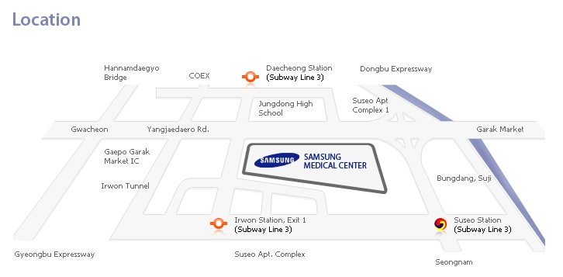

www.samsunghospital.com/global/en/information/location.jsp

▣ COEX Conference Room (south) #308

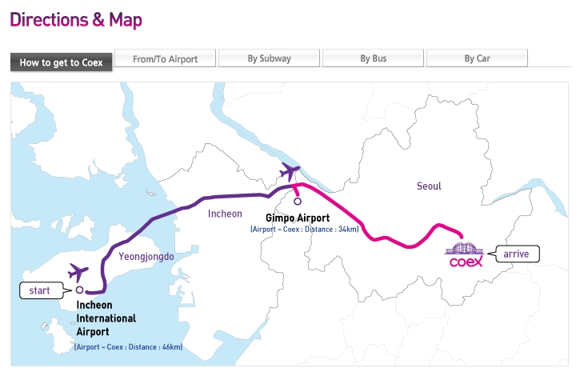

www.coex.co.kr/eng/visitors/directions_tab01.asp

The Scientific Meeting of Asian Chapter of Neurosonology Research Group
& 2010 Annual Meeting of the Korean Society of Neurosonology
with International Neurosonology Exam of
American Society of Neuroimaging

Registration Form

Please fill out the form below * Fields with (*) must be filled out.
* Country
* Last Name
Middle Name
* First Name
* Institute
* Department
* Address
* Telephone
* E-mail | @
* Fax
* Degree | □ M.D. □ Ph.D. □ Resident  □ Sonographer □ Nurse □ Others
▪ Please check the box next to the applicable
* Participation | □ Oct 16th □ Oct 17th □ Oct 16th and 17th  □ Oct 17th International Neurosonology Exam of American Society of  Neuroimaging : Please personally apply & pay for exam on website  www.asnweb.org, www.neurosonology.or.kr
Registration  fee | Pre-registration (Till Sep.30.2010) | KRW 40,000  (USD 40) | On-site registration | KRW 50,000  (USD 50)
▪ If you would send completed form to our fax or e-mail till Sep.30,
pre-registration will be completed
▪ Please pay on-site at the meeting in cash
E-mail : ls@ls-comm.co.kr
Fax : 82-2-476-6719
▣ After checking your registration form, a confirmation mail will be sent.

